**#CedefopPhotoAward 2019 exhibition opens in Thessaloniki**

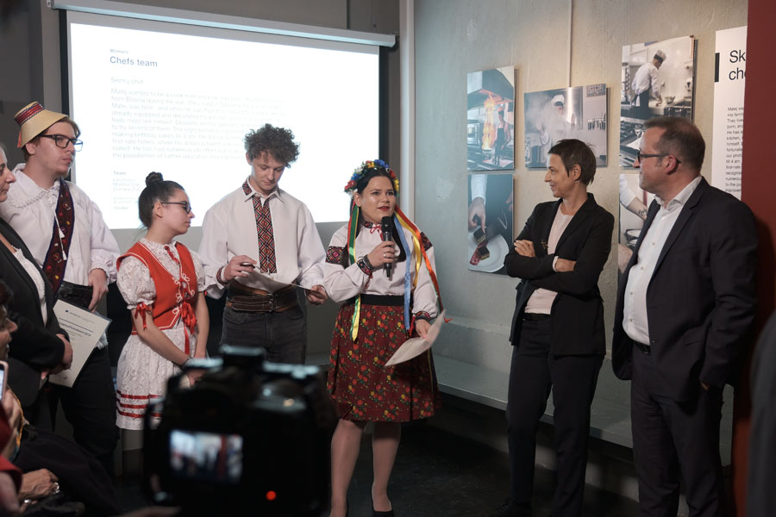

**Image copyright:**

© Cedefop, 2019/Aris Deliopoulos

**Cedefop Executive Director Jürgen Siebel and Thessaloniki International Film Festival General Director Elise Jalladeau opened the #CedefopPhotoAward 2019 exhibition at the Thessaloniki Cinema Museum on 1 November.**

The exhibition, which will be open to the public until 30 November, showcases the photostories of the award’s three winning teams and 17 runners-up. The winners of the *Prix du Jury* from Romania, dressed in traditional costumes, received their certificates during the ceremony.

Mr Siebel welcomed the students and teachers from two local vocational schools who were invited to the ceremony and noted that, when Cedefop established the photo award four years ago, it wanted to give a voice to vocational education and training (VET) learners across Europe and promote VET as a first educational choice.

Introducing the winners of the *Prix du Jury*, a group of learners from the Marmaţia Technological High School in Maramureș who studied business and set up their own micro-company to produce and sell local artefacts, he praised their effort to portray how tradition and art can become a source of inspiration, even to start one’s own professional venture.

Ms Jalladeau said that the team is an example of creativity and diversity as its members have different ethnic origins (Romanian, Hungarian and Ukrainian). ‘Europe is about diversity,’ stressed Ms Jalladeau ,adding: ‘It’s the fourth year we are welcoming young people from all over Europe as part of our collaboration with Cedefop, and it’s great to see gifted and enthusiastic Europeans from different backgrounds producing such beautiful photostories.’

The other two [**winning teams**](https://www.cedefop.europa.eu/en/news-and-press/news/cedefopphotoaward-2019-winners-announced), from Austria and Croatia, went head to head for the #CedefopPhotoAward 2019 top prize, which was announced at the European vocational skills week celebrations in Helsinki (14-18 October), following a public online vote. It was the Austrian photostory that got the most votes.

In total, 112 teams from 20 European countries, consisting of 380 VET learners and 76 teachers/trainers representing 73 learning providers, took part in this year’s #CedefopPhotoAward. The learners were asked to share a photostory of a memorable VET experience.

Find out more about the [**winners and runners-up**](https://www.cedefop.europa.eu/en/news-and-press/news/cedefopphotoaward-2019-winners-announced) of #CedefopPhotoAward 2019.